1) Variables and primitive types

Agenda
- Intro to programming
- Variables
- Input
- If/else

Start of the course
Instructor and the students introduce themselves. Students state their names, reasons why they joined the course and if they have any prior knowledge.

Intro
Computers are now everywhere. Not only on our desks (desktop computers), but also in our pockets (mobile phones) in our car, house etc. Their job is to help us with every day tasks. They are our own assistants.
We give computer a task and computer executes this task. Humans can give a task in different ways: via mouse, keyboard, touch (on touchscreen) or microphone (voice commands). All these are called inputs.
When computer does some task, it gives back a result via output: screen, speakers, vibrator (in a mobile phone) etc.
For example: when you go to bed at night and you set up an alarm on your mobile phone, you use touchscreen to do this (input). Computer remembers the task and executes it in the morning by making a large sound via speakers (output).
In order to give a task to computer (like setting up an alarm), you have to use a computer program (on mobile phones we call it app or application). Computer program is a set of instructions that computer can understand.
Example: Imagine that you are a very good cook or chef and you just created a new amazing dish. You'd like to share it with the world so other people can cook it too. What do you do? You write a recipe.
Programs are recipes for computers. And programmers are digital chefs.
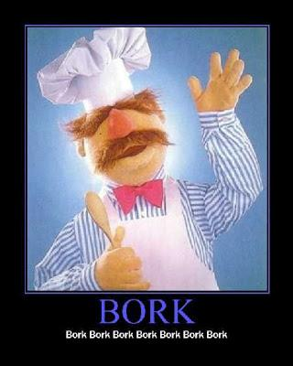

What is programming anyway?
Programming is basically writing commands (or set of instructions) for our computer to execute. We write these commands in one of the programming languages, which is then automatically translated to the machine code (binary code: zeros and ones) which computer processor (or computer's brain) can then execute.
A simple task to understand programming (without actually programming) would be to write down a set of instructions to make a sandwich. This could look something like this:
- Open a kitchen cabinet.
- Take out a plate.
- Put a plate on the table.
- Close a kitchen cabinet.
- Open a fridge.
- Take out salami.
- Put salami on the table.
- Find cheese.
- If there's cheddar cheese, take cheddar.
- If not, take gouda cheese.
- Put cheese on the table.
- etc.
As you can see, you have to be very specific with commands. The above example might even be too little specific. You have to know that computers are not as smart as humans are (yet), so you have to tell them precisely what you want from them.
Ok, enough mumbo jumbo - let's get to action!

Create a Python project via PyCharm
- Open PyCharm and click on Create New Project
- Select the right location for your project folder and type in the name of your folder (the folder does not have to be created yet, PyCharm will create it for you)
- Virtual environment location: Use a separate folder (outside your project folder) to create a virtual environment in.
- Also make sure you have Python 3 selected as your Base interpreter (should be by default, but check anyway).
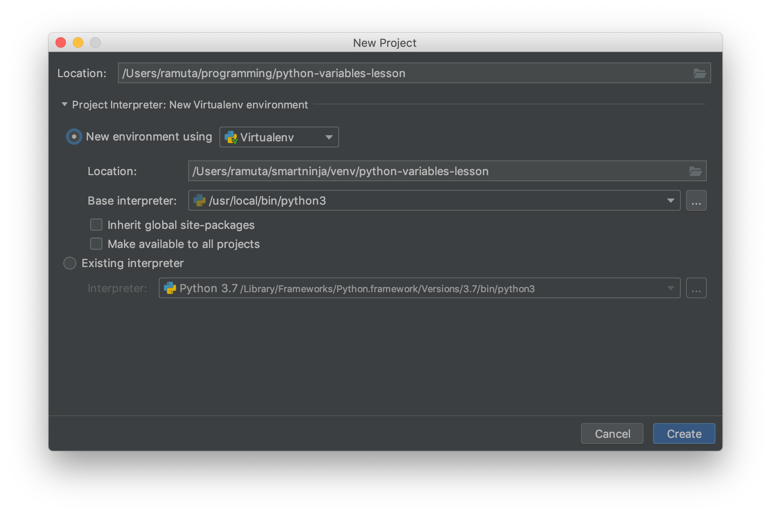
When the project is created, also create a new Python file and name it main.py.
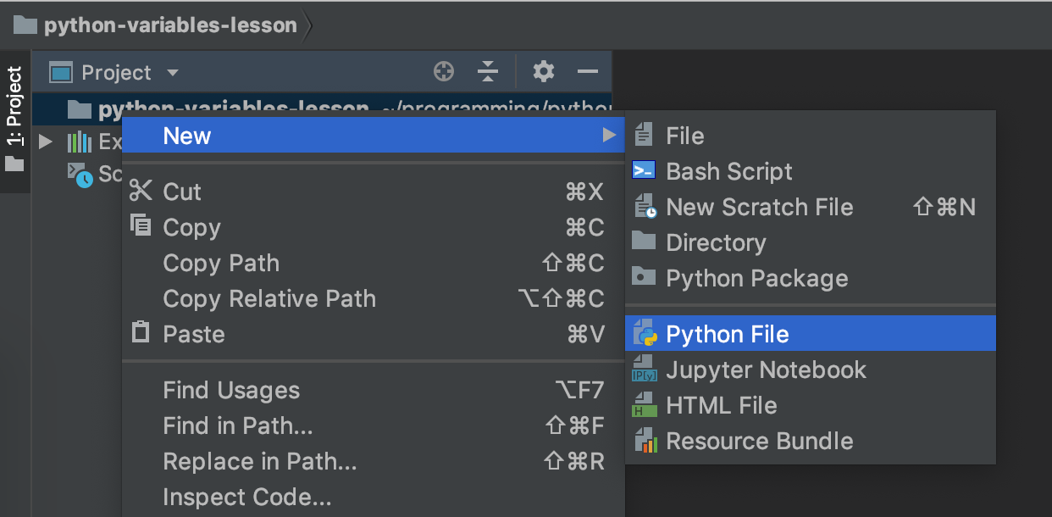
Let's dive into the first programming topic: variables.

Variables
Variables are a basic element of any programming language. Actually each of us has already met variables. Where? In the math class in school. The concept of variables basically means that you save (or store) some value under some name.
Remember this from math? We stored a value 5 under a name x. And value 2 under name y. And then we calculated the sum of these two values (using their names).
We do the same in programming when we store values into some variable.
Let's write it in our Python program:
And now we'll use a very useful Python function to show the result of adding these two numbers together:
Print does not mean that the result will be printed on a piece of paper via your printer.
Instead, the result will be printed in the Python console. The console is a nice tool that will help us see what our Python programs are doing.

Running the Python program
Let's run the Python program, so we can see the result in the console.
Right-click on main.py and select "Run main":
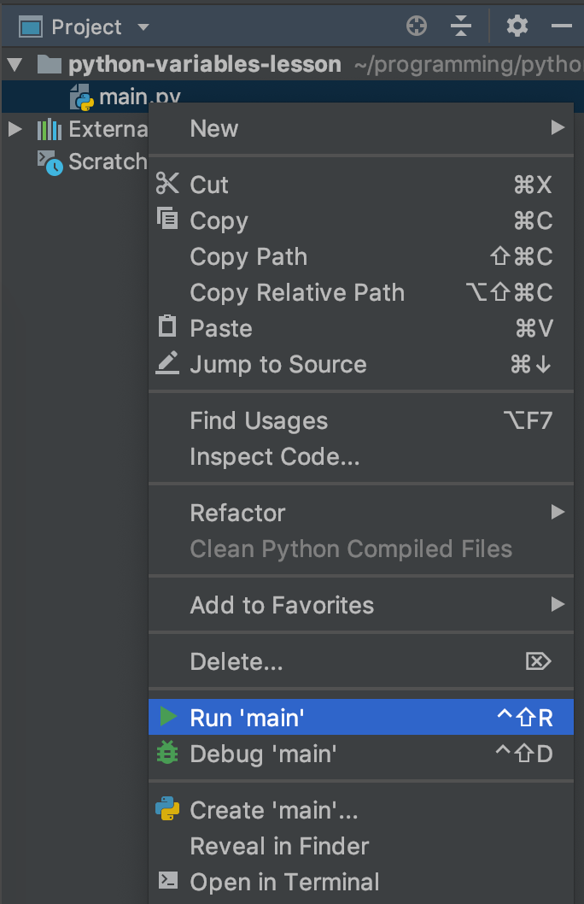
As you'll see, PyCharm will automatically open the Python console in the bottom of the screen:
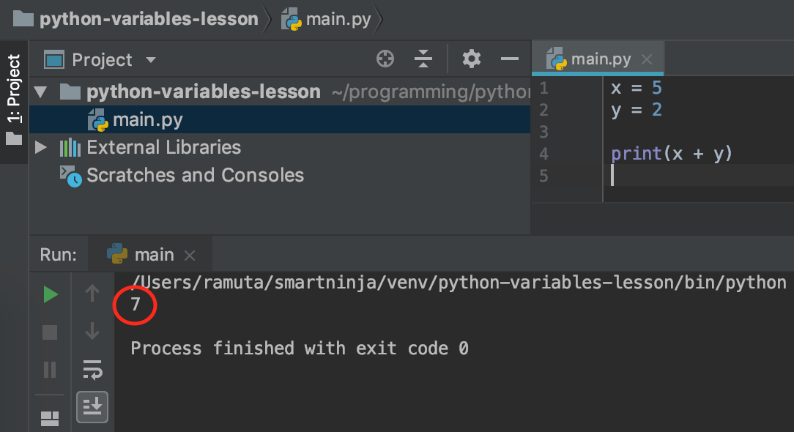
You can see the computer correctly calculated the result: 7.
You have just created your first Python program. Congrats! :)

More than just numbers

Strings
But we can do so much more in programming than just dealing with numbers. We can also store letters and words into variables:
We call this data type a string, which means a sequence of characters.
A string can hold either one character, multiple characters or none at all. See the following examples:
Anything can be a string, as long as it's written in-between quote marks: " or '.
We can also join strings:

Boolean
Another interesting variable type is called a boolean. It's very simple, actually, it's either True or False. So only two options here:
You'll find out later on where this might come in handy. For now just know that this exists.

Nothing
Yes, we can even code nothing. Sounds funny, right? But when you think about it, it's pretty logical. We can say that some variable does not hold a value (yet):

We can still assign it a value later though.

Primitive data types recap
These are the main primitive data types in Python:
- Integer: a whole number, such as 3 or 25
- Float: a decimal number, such as 2.5 or 23.764 (remember to use dot for a decimal point, not a comma!)
- String: a sequence of characters, always within quote marks. Example: "this is a string"
- Boolean: boolean has only two possible values, either True or False
- nothing: a variable can have no value. In Python we denote this as None
We can imagine a variable like a cup in which we can store (put) some value - the same way as we put coffee into a coffee cup :)
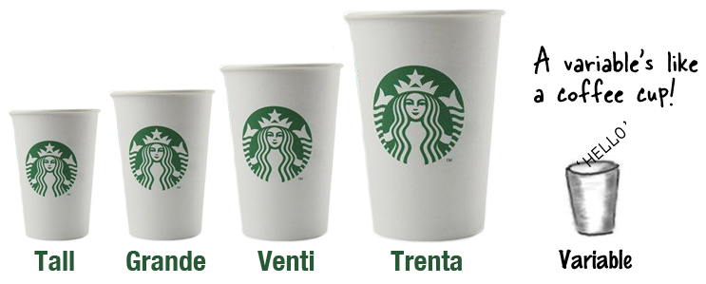
If we don't store any value in a variable (for example: x = None), it means the cup is empty.

Bonus: comments
Comments are a part of code that your computer will ignore. In Python we use #:

User's input
Let's make our Python programs more interactive. We'll let anyone that uses the program to enter some data via Python console and the program will respond to this data.
We'll do this by using a nice little function called input(). Let's see how it works:
First we'll ask the user to enter her/his name into the console. When the user will enter the name and hit Enter, our program will print out "Hello" and the user's name.
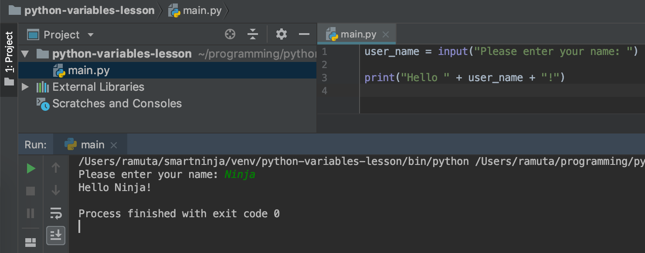
Pretty cool, right?
Now let's try to create a simple calculator that adds two numbers that the user writes in:
Let's run this program:
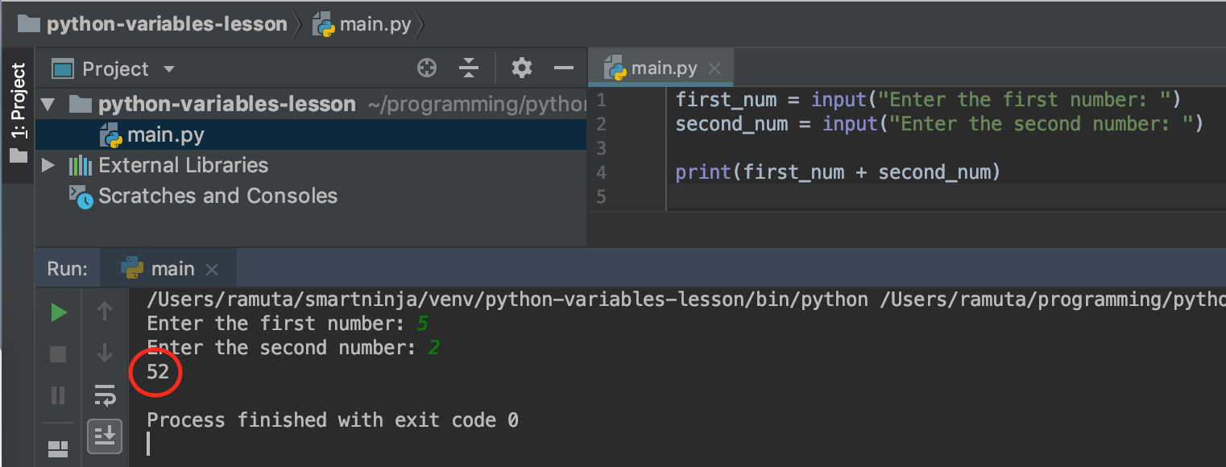
Oops! Something is not right. The result should be 7, not 52! What happened?
Well, let's get back to variable types. More precisely to strings and integers.
If we add two integers, we get the correct result:
But if we write numbers as strings (quote marks), what do we get?
We get a result "52". Because we just joined two strings together, "5" and "2". Remember: Anything that's written inside the quote marks (even if it's a number) is always a string.
The solution is to change a string into a number. We do this using the int() function:
Now the result is correct.
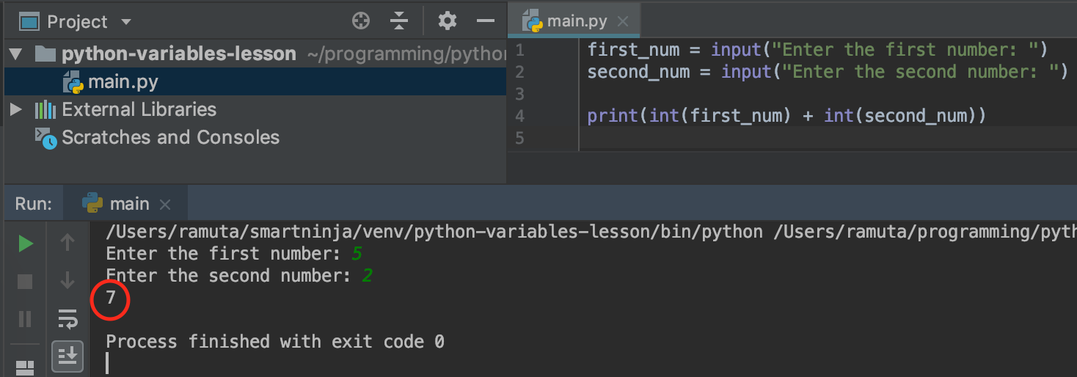
Let's update our calculator example:
The result is now 7. Yaaay! :)
As you can see, we can wrap one function (input()) with another (int()).

If/else
The last thing we'll learn today are if/else statements. I'm sure you already used them somewhere, perhaps when using an Excel spreadsheet.
If we use an if/else statement, we basically tell our program to either execute one part of the code or the other.
Let's see an example:
So if the mood is "happy", the program will print out "It is great to see you happy!".
If it's anything else than "happy", it will print out "Cheer up, mate!".
Important: Note one more thing. When we check if the mood equals "happy", we use double equal sign: ==. This is not a mistake.
In programming, we use single equal sign (=) to assign a value. And we use double equals (==) to check for equality. This is a very important distinction!

Elif
elif is short for else if. This keyword helps you add more options into your if-else statement:
Code indentation is very important in Python because this way computer can know what part of the code belongs to if, and what to else. Create indentation with either 4 spaces or with a Tab button.

Q&A
Any question regarding today's topic?

Homework 1.1: The mood checker
If there's enough time, student's can start working on the homework at this session already.
For the first exercise let's continue the mood checking program from before. Ask user to tell you what mood s/he is in:
- if the mood is "happy", the program should print out "It is great to see you happy!"
- if the mood is "nervous", respond with "Take a deep breath 3 times.". Use elif to enter more if statements: elif mood == "nervous":.
- Make up responses also for "sad", "excited" and "relaxed".
- The last option should be the normal else, which responds with "I don't recognize this mood".

Homework 1.2: Guess the secret number
We have a first customer - a local Casino! They want to expand their business to computer gambling so they want us to build a gambling game for them. For the beginning something small and simple - a game called Guess the secret number.
Your task is to create this game:
- First "hard-code" some number in the program (write the number into a variable). You can call this variable secret.
- Then the user has to find out what this number is (using input()). Store user's guess in a variable called guess.
- Check if your secret is equal to user's guess.
- If the user's guess is wrong, let him/her know that (use print() and if/else).
- If the user's guess is correct, congratulate him/her.

Homework 1.3: Calculator
Write a program that does the basic arithmetic operations:
- addition (+),
- subtraction (-),
- multiplication (*),
- and division (/).
Ask the user to enter two numbers and the arithemtic operation ("+", "-", "*" or "/").
Then use if/elif/else statements to do the right operation. A hint:

